29.19: a) 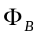is ⊙ and increasing so the flux 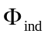 of the induced current is clockwise.
b) The current reaches a constant value so 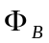 is constant. 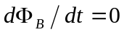 and there is no induced current.
c) 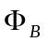 is ⊙ and decreasing, so is ⊙ and current is counterclockwise.

